2016 Mock Caldecott Ballot
Please vote for your TWO favorite books. There will be a Mock Caldecott Medal winner and three honor books.
 | 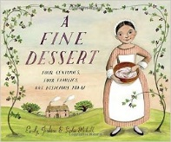 | A Fine Dessert – Sophie Blackall |  |  | My Cousin Momo – Zachariah OHora
 | 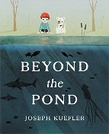 | Beyond the Pond – Kuefler |  | 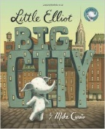 | Nature’s Perfect Package: Egg – Steve Jenkins
 | 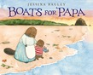 | Boats for Papa – Jessixa Bagley |  | 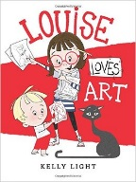 | The Night World – Mordicai Gerstein
 | 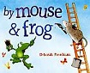 | By Mouse & Frog – Deborah Freeman |  | 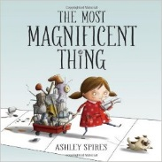 | Red: A Crayon’s Story - Michael Hall
 | 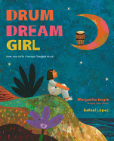 | Drum Dream Girl – Rafael Lopez |  | 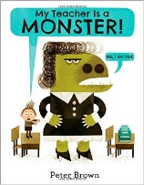 | Special Delivery – Matthew Cordell
 | 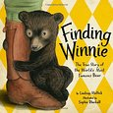 | Finding Winnie – Mattick |  | 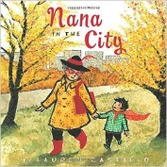 | Swan: The Life and Dance of Anna Pavlova – Julie Morstad
 | 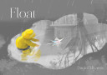 | Float – Daniel Miyares |  | 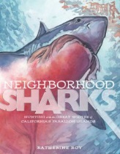 | Toys Meet Snow – Zelinsky
 | 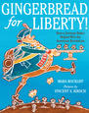 | Gingerbread for Liberty! – Vincent X. Kirsch |  |  | Wait – Portis
 | 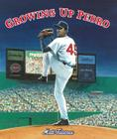 | Growing Up Pedro – Matt Tavares |  | 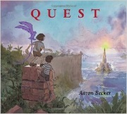 | Waiting – Kevin Henkes
 | 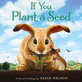 | If You Plant a Seed – Kadir Nelson |  | 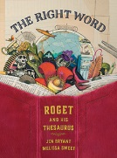 | Water Is Water – Paul
 | 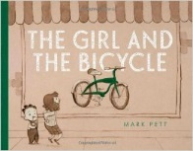 | In Mary’s Garden – Tina Kugler |  | 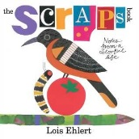 | The Whisper – Zagarenski
 | 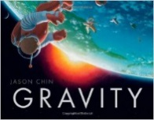 | Last Stop On Market Street – Christian Robinson |  | 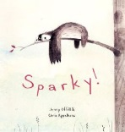 | Wild About Us! – Janet Stevens
 | 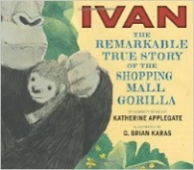 | Lenny & Lucy – Erin E. Stead |  | 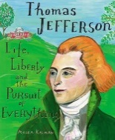 | Wolfie the Bunny – Zachariah OHora
 | 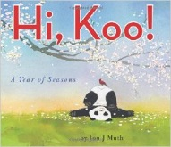 | Leo: A Ghost Story – Christian Robinson |  |  | Yard Sale – Lauren Castillo

